Three tangents problem
Prove that : GE = FH

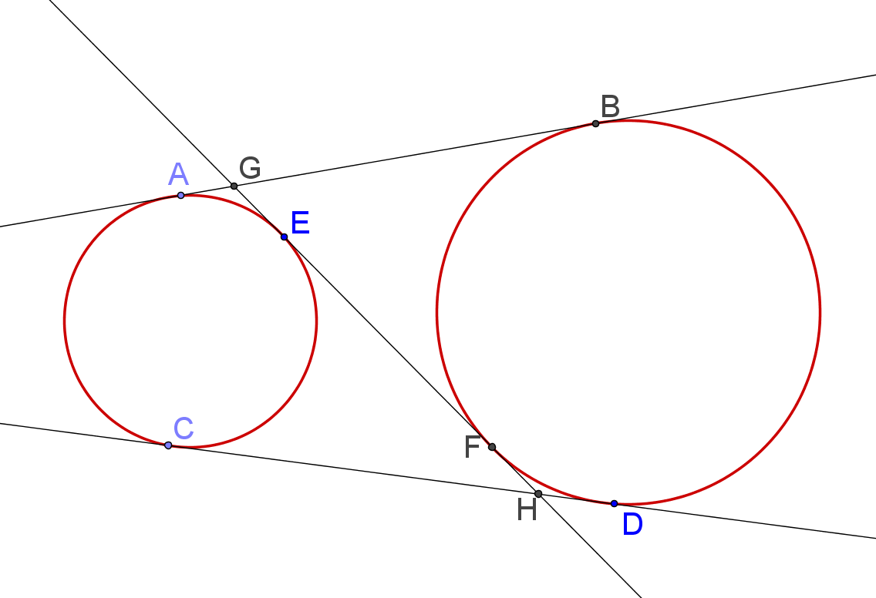


(1) AB = CD

(2) AB = AG + GB = GE + GE
= GE + (GE + EF)
= 2GE + EF

(3) CD = CH + HD = EH + FH
= (EF + FH) + FH
= EF + 2FH

(4) By (1), (2) and (3), GE = FH
Yue Kwok Choy
5, April, 2015

